The profile of Harvey Milk and his fight for gay rights

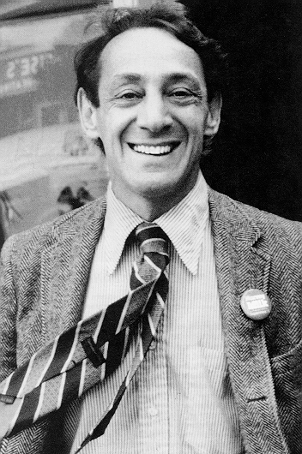

By Adrian Drabner

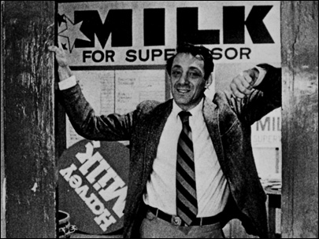
Harvey Milk is a very important man in the history of United States civil rights. Gay rights have been a hot topic in the United States for a long time now and Harvey Milk opened the door for discussion for it since he said he would not silently sit in the closet anymore. Fighting for gay equality back in the late 1960’s was a hard thing to do since Americans still had the very strong family unit mentality. A majority found homosexuality as something that was wrong and a threat to their families. At this time, even having homosexual relations in a rented apartment could get you evicted. There were constant raids at bars arresting homosexuals in New York and San Francisco and it was scary for anyone come out as gay.
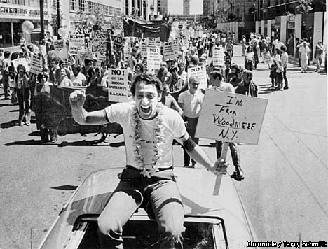
Harvey Milk was born in Brooklyn, New York and served the U.S. Navy for four years. Living in Brooklyn for a majority of his life, Milk moved to Texas but then back to New York since he didn’t like it there. Then Milk decided to move to San Francisco after hearing about the acceptance of the city towards the gay community. When he arrived in San Francisco, Milk opened up a camera store with his partner and campaigned to run for office as an openly gay man. Milk strived to avoid violence but pushed for protests to fight for equal gay rights since Milk knew that the root cause of the gay predicament was invisibility. His friends and peers remember him as an extrovert with a keen sense of humor while also being fantastic speaker and leader of his neighborhood. Being strongly against violence and the bigotry of religious groups, he is known for saying, “The fact is that more people have been slaughtered in the name of religion than for any other single reason. That, THAT my friends, is true perversion.” Milk entered the political arena for the first time in 1973. Angered by the Watergate scandal and by a variety of local issues, he decided to run for a spot on the Board of Supervisors, San Francisco's city council. Using the gay community as his base of support, Milk sought to forge a populist coalition with other disenfranchised groups, including several of the city's diverse ethnic groups. His campaign slogan, "Milk has something for everybody," reflected this approach. Of the 32 candidates in the race, Milk came in tenth, not a bad showing for a long-haired, openly gay Jewish man with no political experience and relatively meager campaign funds. Though he lost the election, he gained enough support to put him on the city's political map. Because of his popularity in his own largely gay district, he became known as the "Mayor of Castro Street."
Milk spent much of the next year preparing for his next election campaign. He cultivated a more mainstream look and gave up smoking marijuana. He also revitalized the Castro Village Association as a powerful civic organization, and launched the popular Castro Street Fair. In addition, he conducted a voter registration drive that brought 2,000 new voters onto the rolls, and he began writing a newspaper column for the Bay Area Reporter. While on his campaigning, Milk would also start off by saying, “My name is Harvey Milk and I'm here to recruit you.”
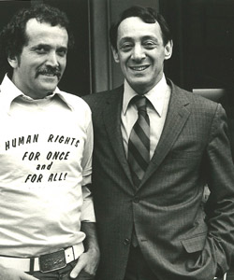
Milk ran for supervisor again in 1975, this time wearing a suit and short hair. Although he gained the support of several important labor unions, he lost again, this time placing seventh, just behind the six incumbents. In recognition of Milk's growing power base, however, newly-elected Mayor George Moscone appointed Milk to the Board of Permit Appeals, his first public office. After just a few weeks, however, Milk announced his intention to run for the state assembly. That disclosure led to his removal from his city post. Running against the entrenched Democratic Party apparatus on the campaign theme "Harvey Milk vs. the Machine," Milk lost yet again, by a mere 4,000 votes. By this time, however, he had established a formidable political machine of his own, the San Francisco Gay Democratic Club. In 1977, on his third try, Milk was finally elected to the Board of Supervisors, becoming the first openly gay elected official in the city's history.
“If I turned around every time somebody called me a faggot, I’d be walking backward – and I don’t want to walk backward.”
As the first openly gay elected official, he was aware of the tremendous discrimination and prejudice that confronted gays and lesbians. Under his urging, the city council passed a Gay Rights Ordinance in 1978 that protected gays from being fired from their jobs. Milk championed the cause of those with little power against downtown corporations and real estate developers, campaigning especially hard for the rights of senior citizens. During this time, Milk knew he was a target of violence and said, “If a bullet should enter my brain, let that bullet destroy every closet door.”
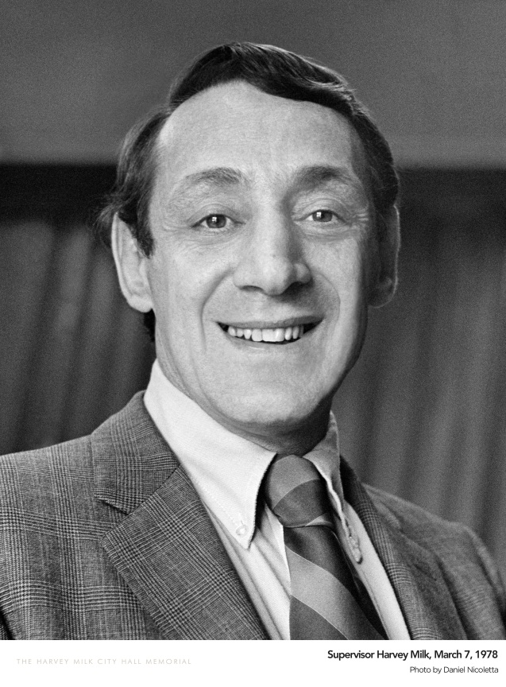
When Milk was elected, many psychiatrists still considered homosexuality to be a mental illness and there were no real national gay organization. One of Milk’s fellow supervisors, Dan White, was upset with the growing official tolerance of gays and disagreed with a lot of Milk’s positions and they often butted heads on issues. With the passing of the Gay Rights Ordinance, Dan White abruptly resigned from his position. Milk was ecstatic about his victory and held large parties to celebrate not only his victory, but the victory for the gay community and he knew it was a step forward for gay rights in all of America.
On November 27, 1978, Dan White entered City Hall with a loaded .38 revolver. In order to avoid the metal detectors, he entered through a basement window that had been left open for ventilation. He then went to the Mayor's office where the two men began arguing until Moscone suggested going to a more private room so that they couldn't be heard. Once there, Moscone refused to re-appoint him and White shot the Mayor twice in the chest and twice in the head.
White then went down the corridor and shot Milk, twice in the chest, once in the back and twice again in the head. Soon after, he turned himself in at the police station where he used to work. There are reports that his old colleagues cheered and applauded him when he arrived.
Harvey Milk was a man with lots of ambition and fought for what he believed in. Despite his short career in politics, Milk became an icon in San Francisco and "a martyr for gay rights", according to University of San Francisco professor Peter Novak. Gay rights have come a long way since Harvey Milk was alive, and we have him to thank. “I fully realize that a person who stands for what I stand for, an activist, a gay activist, becomes the target or the potential target for a person who is insecure, terrified, afraid, or very disturbed with themselves.”

